Accessing filesystem
locate, find command advanced usage:

- Locate
The locate command is used to quickly find files and directories using a pre-built database, making it much faster than find
Updating the Locate Database
The locate command depends on a database (usually /var/lib/mlocate/mlocate.db).
To update it manually:
sudo updatedb
👉 This is often run automatically by a daily cron job, but if you’ve just created or deleted files and want locate to reflect that immediately, use updatedb.
a . Case-Insensitive Search
locate -i readme
b. Limit Number of Results
locate -n 10 passwd
Using Wildcards / Patterns
locate "*.conf"
Filtering Results with grep
locate .log | grep -E "/var/log|/tmp"
Excluding Certain Paths
locate .log | grep -v "/var/log"
5. Practical Examples
- Count how many .log files are in the system
- locate -c .log
- Find all .sh scripts under /home
- locate -r '^/home/.*\.sh$'
- Find all .conf files but limit to first 15 results
- locate -n 15 ".conf"
- Search for passwd ignoring case and show only existing files
locate -i -e passwd
Feature | locate | find
Speed | Very fast (uses a DB) | Slower (searches live FS)
Real-time | Requires updatedb to refresh | Always real-time
Regex support | Via -r | Built-in via -regex
Storage concepts: filesystem, mount, block devices
1. Block Devices – The Raw Storage
Think of block devices as the physical or virtual storage hardware that provides raw space to the operating system.
🧰 Examples of block devices:
- Hard disks → /dev/sda, /dev/sdb
- Partitions → /dev/sda1, /dev/sda2
- USB drives → /dev/sdc1
- Cloud volumes (EBS in AWS, etc.)
- LVM logical volumes → /dev/mapper/vgname-lvname
👉 These devices store raw data blocks. They don’t have any structure until you create a filesystem on them.
You can list block devices with:
Lsblk
Filesystem – The Structure on Storage
A filesystem is like the “format” of the disk.
It organizes data into files, folders, metadata, permissions, etc.
👉 You create a filesystem on a block device or partition, then mount it to access it.
🧰 Common Linux filesystems:
- ext4 → Most common on Linux
- xfs → Default in RHEL/CentOS 7+
- btrfs, zfs → Advanced features (snapshots, compression, etc.)
- vfat, ntfs → Used for Windows/USB compatibility
To create a filesystem (e.g., ext4) on /dev/sdb1:
sudo mkfs.ext4 /dev/sdb1
To check filesystems:
lsblk -f
🗂️ 3. Mount – Making Storage Accessible
Even if you have a filesystem on a disk, you can’t use it until you mount it.
👉 Mounting is the process of linking a filesystem to a directory in the Linux directory tree.
For example:
sudo mkdir /mnt/data
sudo mount /dev/sdb1 /mnt/data
- /dev/sdb1 = the device (with filesystem)
- /mnt/data = the directory where it becomes accessible
Now if you run:
df -h
4. Permanent Mounting (Using /etc/fstab)
Mounting using mount is temporary — after a reboot, it’s lost.
To make it permanent, you add an entry in /etc/fstab:
/dev/sdb1 /mnt/data ext4 defaults 0 0
Then run:
sudo mount -a
to test the configuration.
1. defaults (Mount options)
This is the 4th field — mount options.
- defaults is a shortcut that includes standard options:
  - rw – read/write
  - suid – allow set-user-identifier bits
  - dev – interpret device files
  - exec – allow execution of binaries
  - auto – mount automatically at boot
  - nouser – only root can mount
  - async – asynchronous I/O
You can replace defaults with custom options like noexec, ro, noauto, etc., if needed.

2. 0 (Dump)
This is the 5th field — dump flag.
- It controls whether the dump utility should back up this filesystem.
- 0 = do not include this filesystem in backups.
- 1 = include in backups (rarely used nowadays).

3. 0 (Pass)
This is the 6th field — fsck (filesystem check order during boot).
- It tells the system whether to check the filesystem at boot and in what order.
- Values:
  - 0 = do not check
  - 1 = check first (usually for / — root filesystem)
  - 2 = check later (for other filesystems)
So in your example:
/dev/sdb1 /mnt/data ext4 defaults 0 0
- defaults: Standard mount options
- 0: Do not dump (backup)
- 0: Do not check filesystem on boot

Concept | Analogy
Block device | Blank external hard drive
Filesystem | Formatting the drive
Mount | Plugging it into your PC and opening it in “My Computer”

Quick Example Workflow
- Attach a new disk /dev/sdb
- Partition it with fdisk /dev/sdb → create /dev/sdb1
- Format it → mkfs.ext4 /dev/sdb1
- Create mount point → mkdir /mnt/data
- Mount it → mount /dev/sdb1 /mnt/data
- Make permanent → add to /etc/fstab

✅ Summary:
- Block devices = the raw storage (disks, partitions)
- Filesystem = the structure/format to store files
- Mount = attaching that filesystem to the Linux directory tree
Real-World Scenarios
- 🧠 SATA: Good for OS drives, home directories, or backup volumes.
- 🏢 SAS: Ideal for enterprise storage arrays, critical databases, or virtualization clusters.
- ⚡ NVMe: Best for applications needing high IOPS and low latency — e.g., MySQL, Redis, big data, CI/CD cache storage.
- 🕰️ SCSI: Mostly seen in legacy systems or still used internally by Linux subsystems for compatibility.
Summary

SATA → Common, cheap, slower → general use

SCSI → Legacy, forms basis of SAS → mostly outdated but conceptually important

SAS → Fast, reliable, enterprise-grade → used in servers

NVMe → Next-gen SSD protocol over PCIe → extremely fast, modern choice
What is Disk Partitioning?
👉 Disk partitioning is the process of dividing a physical disk into one or more parts (called partitions) to manage data, OS files, swap, and backups efficiently.
Think of a disk like a book:
- The whole book = the physical disk
- Chapters = partitions
- Table of contents = partition table
Each partition can have its own filesystem, mount point, and purpose.
3. Partition Table Types
When partitioning, the partition table defines how the disk structure is stored.
🧾 a. MBR (Master Boot Record) – Legacy
- Max 4 primary partitions
- Supports disks up to 2 TB
- One partition can be “extended” to create logical partitions inside
🧾 b. GPT (GUID Partition Table) – Modern
- Supports 128 partitions by default (no need for extended)
- Supports disks larger than 2 TB
- More reliable (keeps multiple copies of partition table)
- Used in UEFI-based systems
👉 GPT is now the standard for modern systems.
Types of Partitions
- Primary partition – Bootable; up to 4 in MBR
- Extended partition – Container for logical partitions (MBR only)
- Logical partition – Inside extended partition
- EFI System Partition (ESP) – Required for UEFI boot
- Swap partition – Acts like virtual RAM
Primary Partition
- Definition:
A primary partition is one of the main partitions on a disk. It can store an operating system or regular data.
- Key Points:
  - You can create up to 4 primary partitions on a disk using the MBR (Master Boot Record) partitioning scheme.
  - One of these primary partitions can be marked as bootable, meaning the system’s BIOS will look here to boot the OS.
  - In GPT (GUID Partition Table), you can have up to 128 partitions, so this limitation doesn’t apply.
- Usage Example:
If you install Windows or Linux on a disk with MBR, typically the OS will be installed on a primary partition like /dev/sda1.

🧱 2. Extended Partition (MBR Only)
- Definition:
An extended partition is a special type of primary partition that acts like a container for more partitions.
- Why it exists:
Because MBR only allows 4 primary partitions, the extended partition was introduced to bypass this limit and let you create more than 4 partitions.
- Key Points:
  - There can be only one extended partition on a disk.
  - You can’t store data directly in an extended partition.
  - Instead, it holds logical partitions inside it.
- Usage Example:
If /dev/sda1 to /dev/sda3 are primary, then /dev/sda4 can be made extended, and inside it you can create /dev/sda5, /dev/sda6, etc.

📂 3. Logical Partition
- Definition:
Logical partitions are created inside the extended partition.
- Key Points:
  - You can create many logical partitions (practically up to 15 or more) depending on the OS.
  - Logical partitions are numbered starting from 5, even if you have fewer primary partitions.
Example: /dev/sda5, /dev/sda6, etc.
  - They function just like primary partitions (you can mount file systems on them, use for data, etc.), but you cannot boot directly from a logical partition on BIOS/MBR systems (without a special bootloader setup).

Concept | Description
Partitioning | Dividing a disk into logical sections
Partition table | Defines layout (MBR / GPT)
Primary partition | Main usable partition
Extended/Logical | Workaround for >4 partitions in MBR
Filesystem creation | Format partitions to ext4/xfs, etc.
Mounting | Attach formatted partition to a directory

Filesystem | Type | Key Features | Best Use Case
ext4 | Native Linux | Journaling, backward-compatible, reliable | General-purpose Linux systems
XFS | Native Linux | High performance, scalable, great for large files | Enterprise workloads, databases, logs
Btrfs | Native Linux | Snapshots, compression, checksums, COW, RAID support | Advanced setups, versioning, data integrity
exFAT/FAT32 | Cross-platform | Widely supported across OSes, limited features | USB drives, SD cards, compatibility
Ext4= Fourth Extended Filesystem
Xfs = Extended Filesystem
Btrfs =Btrfs (B-tree File System)

lsof – List Open Files
👉 Command:
lsof
Example | Description
lsof | Lists all open files by all processes.
lsof /path/to/file | Shows which process is using a specific file.
lsof -i :80 | Shows processes using port 80 (useful for web servers).
lsof -u karan | Lists all open files by user karan.
lsof +D /var/log | Recursively list all open files under /var/log.
lsof -p 1234 | Shows all open files by process with PID 1234.

df – Disk Free
👉 Command:
df
📌 Purpose:
df reports file system disk space usage, i.e., how much space is used and available on mounted file systems.
📝 Common Usage Examples:
Example | Description
df | Shows disk usage for all mounted filesystems.
df -h | Human-readable output (e.g., GB/MB instead of blocks).
df -T | Shows file system type (e.g., ext4, xfs).
df -i | Shows inode usage instead of disk space.

du – Disk Usage
👉 Command:
du
📌 Purpose:
du estimates disk space used by files and directories.
Unlike df (which looks at partitions), du looks inside directories to show where the space is being used.
📝 Common Usage Examples:
Example | Description
du | Lists disk usage for current directory and subdirectories (in blocks).
du -h | Human-readable (e.g., 1K, 25M, 2G).
du -sh /var/log | Shows total size of /var/log.
du -sh * | Shows size of each item in current directory.
du --max-depth=1 -h /home | Shows size of /home and one level inside (quick overview).
du -sh | sort -h | Show all files with disk usage from lowest to highest
Du -sh | sort -hr | Show all files with disk usage from highest to lowest
Du -sh | Du-disk usage s= summary h= human readable
free – Display Memory Usage
👉 Command:
free
📌 Purpose:
free displays information about RAM and swap memory usage in the system.
📝 Common Usage Examples:
Example | Description
free | Shows memory usage in KB.
free -m | Shows memory usage in MB.
free -g | Shows memory usage in GB.
free -h | Human-readable (MB/GB automatically).
watch free -h | Refresh memory usage continuously (like a live monitor).

DAS (Direct Attached Storage) vs NAS (Network Attached Storage) vs SAN (Storage Area Network)
Comparison Table: DAS vs NAS vs SAN
Feature | DAS 🖥️ | NAS 🌐 | SAN 🧠
Full Form | Direct Attached Storage | Network Attached Storage | Storage Area Network
Connection | Direct (SATA/SAS) | LAN (Ethernet) | Dedicated network (FC/iSCSI)
Access Type | Block | File | Block
Users | Single server | Multiple clients | Multiple servers
Speed | Very fast (local) | Depends on network speed | Very high (dedicated fabric)
Sharing | No | Yes (file-level) | Yes (block-level)
Scalability | Limited | Moderate | Very high
Cost | Low | Medium | High
Best For | Single server storage | File sharing / backup | Datacenters / enterprise apps
SAN:
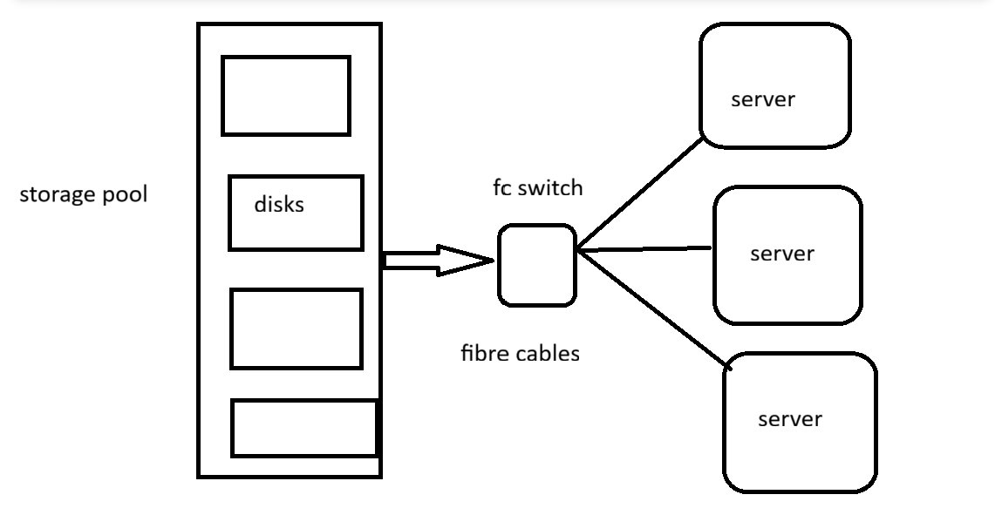
Tasks:
• Partition disk with fdisk and mount FS
• Use find with -exec option
• Compare disk space with df vs du
• Identify processes with open files using lsof
• Mount remote FS (NFS test)
1) setting NFS server
1. Install NFS Server Packages
sudo dnf install nfs-utils -y

📁 2. Create and Configure Shared Directory
sudo mkdir -p /srv/nfs/share
sudo chown nobody:nogroup /srv/nfs/share
sudo chmod 755 /srv/nfs/share
Adjust permissions as needed based on your use case.

📝 3. Configure NFS Exports
Edit the exports file:
this is the configuration file of NFS
sudo nano /etc/exports
Add a line like:
/srv/nfs/share 192.168.1.0/24(rw,sync,no_root_squash,no_subtree_check)
Replace 192.168.1.0/24 with your actual client subnet or IP.

🔁 4. Export the Shared Directory
sudo exportfs -a

🚀 5. Enable and Start NFS Services
sudo systemctl enable --now nfs-server
sudo systemctl start nfs-server

🔥 6. Configure Firewall
sudo firewall-cmd --permanent --add-service=nfs
sudo firewall-cmd --permanent --add-service=mountd
sudo firewall-cmd --permanent --add-service=rpc-bind
sudo firewall-cmd --reload

✅ 7. Verify Exported Shares
sudo exportfs -v

🧪 8. Test from NFS Client (RHEL or other Linux)
On the client:
sudo dnf install nfs-utils -y
sudo mount <server-ip>:/srv/nfs/share /mnt
Make it persistent:
echo "<server-ip>:/srv/nfs/share /mnt nfs defaults 0 0" | sudo tee -a /etc/fstab

